Parallel and Distributed Computing

CSE4001

Fall Semester 2020-21

Lab Assignment 4

**ISHAAN OHRI**

**18BCE0265**

**Aim:**

* Write a simple OpenMP program to demonstrate Arithmetic Operation using Section Clause.

**Source Code:**

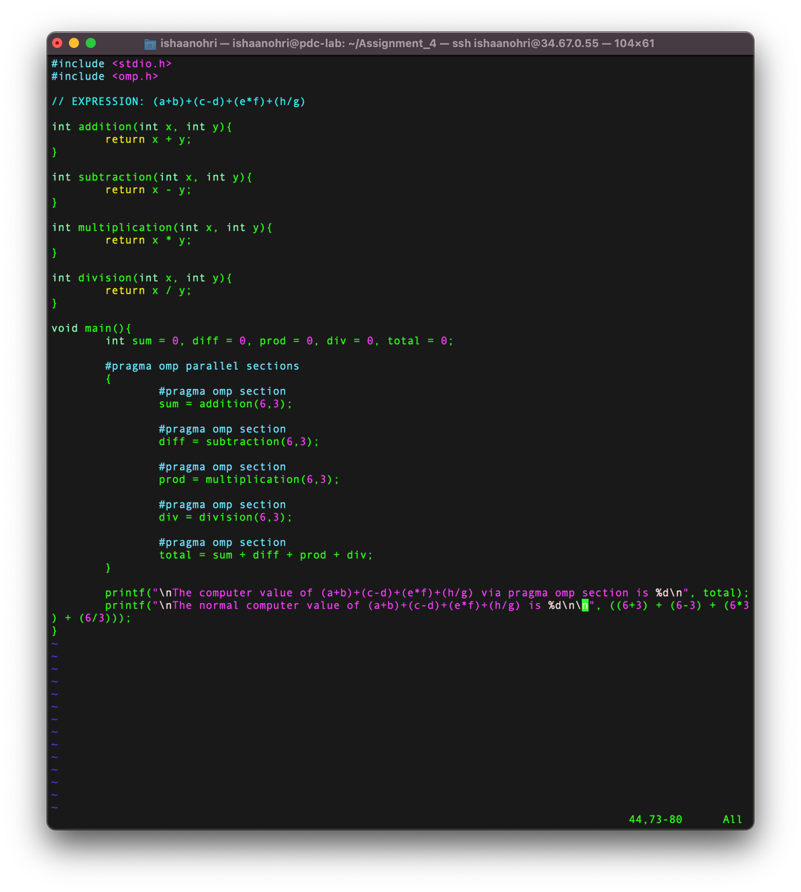

**Execution:**

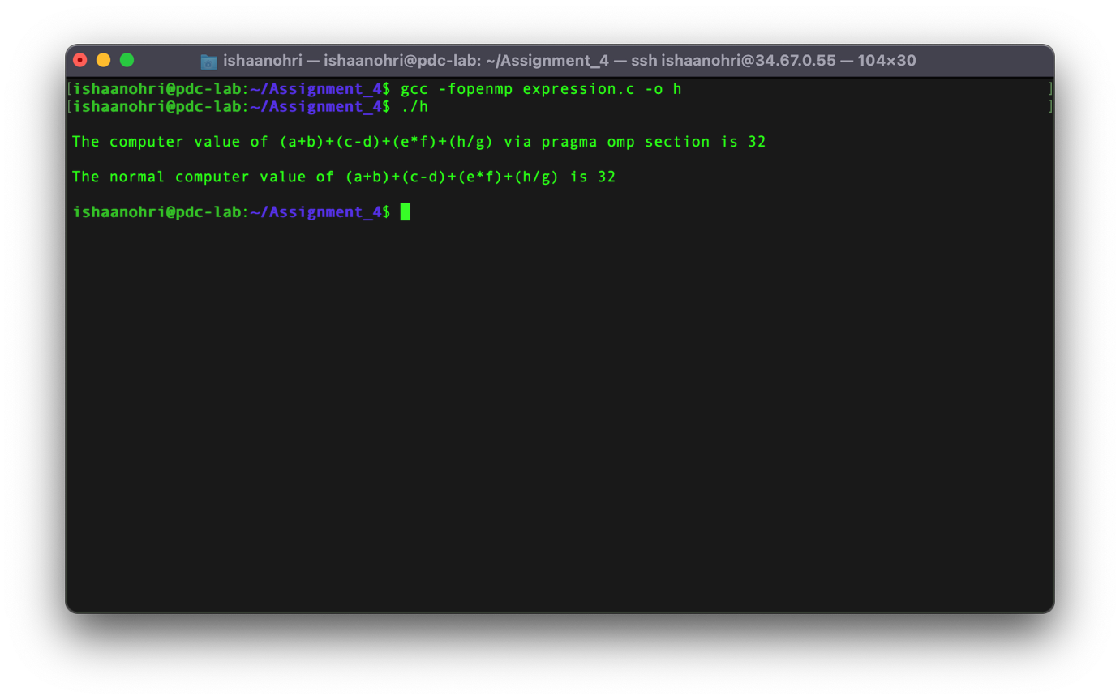

**Result:**

From this experiment I understood the usage of *section* *clause*. By the use of section clause, I verified the result of various arithmetic operations like addition, subtraction, multiplication and division. The results were calculated separately by the use of pragma section and was later verified by comparing with the normal method. The result of both the ways matched and hence was correct.

The above experiment was conducted and all results along with the source code have been attached above in the document. The experiment was assisted by Dr Deepak. I thank sir for his assistance.